**Data Analysis Report Using MS Excel**

**Objective-** Vrinda store wants to create an annual sales report for 2022. So that, Vrinda can understand their customers and grow more sales in 2023.

**Questions to be answered-** By analyzing the data through Excel we’ll be able to give the answers to the following questions-

Q1-> Compare the sales and orders using single chart.

Q2-> Which month got highest sales and orders?

Q3-> Who purchased more men or women in 2022?

Q4-> What are the different order status in 2022?

Q5-> List top 10 states contributing to the sales?

Q6-> Which channel is contributing to maximum sales?

Q7-> Highest selling category? Etc.

**Data Source-** We have got the data in excel format and now we are going to analyze it in detailed way. To do this first thing we need to do is- “Data Cleaning”.

1. **Data Cleaning-** In this we check for null and missing number and also check for duplicate and if any one of the following found then we correct it. As for example in the data table we have ‘W’ instead of ‘Women’ so we have to replace it and correct it.
2. **Data Processing-** In this part of data handling we basically try to figure out calculational part of our data. We try to build different relation based on what we are trying to analyze in the data. Like for example here we are finding the relation between age and gender as one of our tasks. See the screenshot below where we have figured the relation to classify people on basis of age.

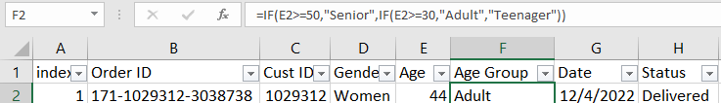

Another thing that we do here is that on the basis of date, we make a new column of month where we extract the month from date column. See screenshot below-

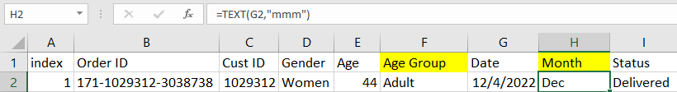

1. **Data Analysis-** The important aspect of data handling is data analysis. Through this we can get many trend analysis in an easy way. It is the best way of expressing the data trend. In this-

* We first create pivot table and using this we make our first graph of Order vs Sales.
* Then we create a new sheet named Vrinda Store Report 2022 and in this sheet, we paste our all required graphs that are necessary for the trend analysis. 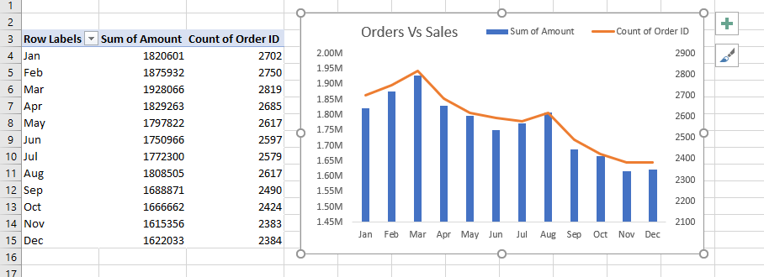
* Using this chart, we can track down month wise sale and orders etc. and along with this we can say that March is the required month here we got maximum sales.
* Then moving further, we create another pivot table for analyzing who shops more men or women. We follow same steps as that of previous to make a pie chart as shown here.

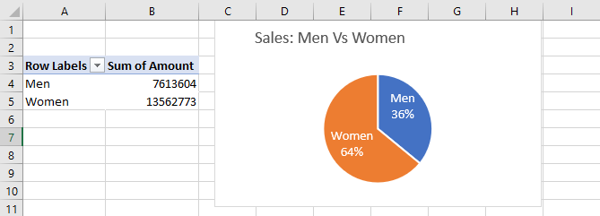

* Using this chart, we clearly see that women shops more than that of men.
* Similarly, we draw another pie chart for order status like how many delivered or cancelled etc.

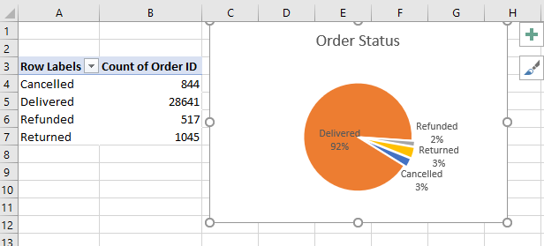

* Another bar chart is drawn for top five states that have maximum sales. 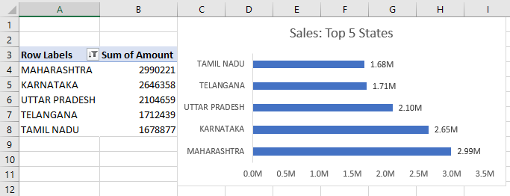
* Then we plotted the chart that shows which age group bought more and all these.

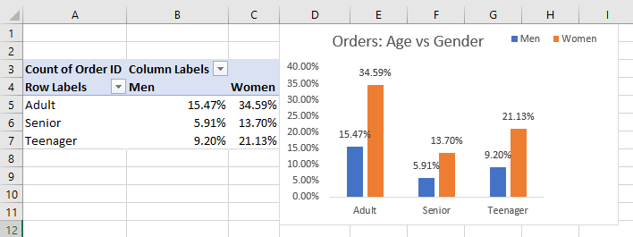

* Lastly, we plot the order vs channel graph to figure out which channel items got most attention etc.

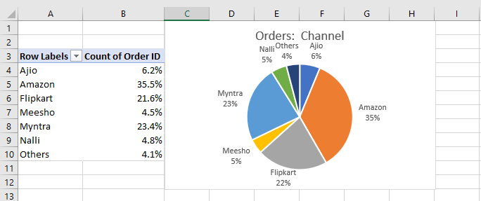

So up to this we have done with all kind of required data analysis part. And using the slicer operation in these pivot table we can make dynamic dashboard to check and analyze different scenarios.

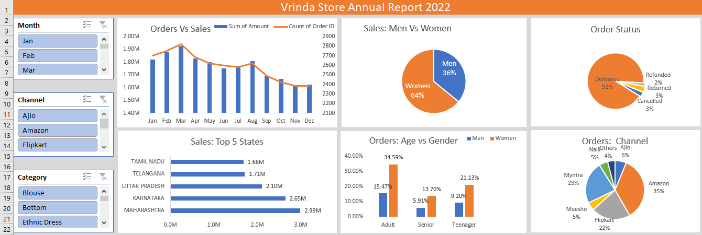

**Insights-** Based on our analysis, few points we get-

(i) Women are more likely to buy compared to men (~65%)

(ii) Maharastra, Karnataka, Uttar Pradesh are top 3 state (~30%)

(iii) Adult age group (30-49 years) is max contributing (~50%)

(iv) Amazon, Flipkart, Myntra are max contributing (~80%)

**Final Conclusion to improve Vrinda Store Sales-**

Target **women** customers of age group (**30-49 years**) living in **Maharashtra**, **Karnataka** and **Uttar Pradesh** by showing ads/offers/coupons available on **Amazon**, **Flipkart** and **Myntra**.